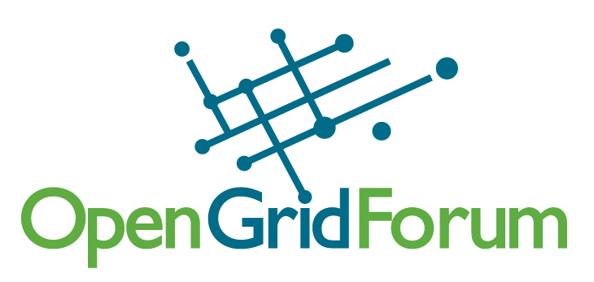
OGF19 PC Call Notes
11/9/06

ATTENDEES:
Ann Collins
Steve Crumb
Mark Linesch
John Hurley
Joel Replogle
Robert Fogel
John Ehrig
Nate Klingenstein
Craig Lee
Gwen Nichols-White

NOTES:
- The PC reviewed the current submissions:
- Reminder that the CFP deadline is Nove.17 and we need more proposals.
- The PC would like to be in a position to coordinate a draft program by December and identify conflicts around draft schedule, that will work around all functions, especially around standards

- Current Proposals: 10
- Note that we’re going to have limited time on the phone, so all PC members need to take time to review proposals not limited to time on phone, engage via email, and make steady progress.

Proposal #1: Introduce: Graphical Creation of Globus Based Grid Services

Proposal #2: The Application Service Grid – SOA meets Grid Computing
Proposal #3: Transactional Grids
- We want vendor participation but don’t want advertising, we need to know more about what Gigaspaces will be talking about.
- Comment: (John Hurley) Not concerned about not knowing, but make sure it’s not the same stuff we’ve heard before. Needs to be interesting and drive conversation. Need put things up that are exciting, engaging, something new (guiding principles)
- ACTION: Contact Geva Perry, find out more about what they will be presenting. Do they know what we’ve done in the past? Chief Marketing, title makes people nervous. Titles are interesting, but how much interesting material will there be? Craig to contact Geva and to have Steve on phone call.

Proposal #4: Secure Replication of Data in the Grid
- We don’t know the presenter, what context are they talking about? Not clear.
- ACTION: Steve to send this to friends in Israel and see if they know them and see if it’s a topic we can include. Steve to find out what their website says about them.

APPROVED Proposal #5: The Second Workshop on Reliability & Robustness in Grid Computing Systems
- Chris has well-attended BoFs. Vote to approve this.
- Craig will contact John about the Metrics on virtual SOAs workshop, have him submit it online.

Proposal #6: GRADIENT – Grid based Enterprise Data Integration Framework
- Gradient – Intriguing, by emphasis, very large systems integrator. Built it on OGSA-DAI. This may be targeted more toward enterprise.
- ACTION: Keep this as a thumbs up and take action on it later.

Proposal #7: GIN-I: GIN and the HPC Profile
- Makes sense to approve this especially in light of SC06. This could be start of a success for us.
- ACTION: Joel, flag this as maybe something we put into a ½ day group session, joint between JSDL, HCPC, BES groups.
- GIN wants to meet with them to have a round-table on this particular subject. Why on Monday? Is this a limitation to Erwin? Perfect day to do this would be Wednesday, but it’s noted as wanting to do it on Monday. Could do a repeat that we’re doing at SC06?

Proposal #8: GIN-II: GIN Feedback to Standards
- Intention was to combine this with overall requirements. GIN operates as a arallel requirements group, another stakeholder group, so they’d be part of the roll-up process.
- ACTION: Robert should drive this directly, talk to Erwin directly, Craig will send email to Robert to use as reference.

Proposal #9: How to Use Benchmarks When Evaluating New Servers
- This is not applicable to our audience.
- Proposal came through as a general speaker interest.
- Not Accepted.

Additional Discussions:
  - Reminder that the CFP deadline is Nov 17 and we need more proposals.
  - The PC would like to be in a position to coordinate a draft program by December and identify conflicts around draft schedule, that will work around all functions, especially around standards
  - Note that we’re going to have limited time on the phone, so all PC members need to take time to review proposals not limited to time on phone, engage via email, and make steady progress.
  - Comment: (Mark Linesch) We should tackle the notion of line between virtualization and grids; would be an interesting theme.
  - Comment: (Robert Fogel) We should look at how they fit relative to each other and how do they make an overall picture. We can then solicit sessions from specific targeted organizations. Enterprise should have more structure, flow, focused on a common theme. Bucket what we have and then look at the holes we need to fill.
  - We need to look for topics that would be interesting for those who attend the Federated Identity workshop, those who come Tuesday, we’d want them to stay for interesting topics on Wednesday. Same thing with Web 2.0.
  - ACTION: Steven Santa Maria: Intel, Robert can find out who he is. Web2.0 conference? Put on OReilly and CMP, put on list for potential partner list.
  - ACTION: John Hurley will take a look at the Web 2.0 conference to see if it’s of interest.
  - Comment: (John Hurley): What about the storage community and the impact of storage. Storage networking community group, it’s moving toward enterprise.
  - ACTION: Joel, track down where group is at, approach group chairs, Alan, Vincent are engaged in that group. They can give some enterprise-oriented content.
  - ACTION: Gwen to send out list of solicitations and confirmations she has received for additional Enterprise content, outside of the Enterprise Roll-up.

Next call Thursday next week – November 16, 11am CT

Next next call: Nov 21st

